Integration of learners with special needs: A socio-cultural clue to debate
Dr. Nadia Idri, Faculty of Arts and Languages, University of Bejaia
Grade: MCA
Email: nadiaidri@gmail.com
Tel: 0774907730

This paper put focus on people with disabilities and their full integration in the learning space. First, the notion of disabled learners is defined from its international standpoint. Then, relation between disability and the Algerian context is made clear. More precisely, the work accentuates sociocultural obstacles such learners face when confronted to their learning spaces. Most of the work relies on theory and new advances in the field of inclusive education from different viewpoints; associative, governmental, research, societal. A number of witnesses from different learning spaces are exposed to explore the difficulties such disabled learners face while moving from their homes to their learning spaces. At the end, a list of recommendations and useful information are presented for a better life for the learners.
Keywords: access to education, disabled learners, learning place, socio-cultural clues, special needs.
Introduction
People with special needs constitute an important part, though vulnerable, in the Algerian society. Algeria created the National Council of Persons with Disabilities (NCPD) in the text 06-145 of 25 of April 2006. However, this council was only effectively established in 2014. Before that, in 2002, there was the ratification of the law 02-09 of 8 May 2002 that Rights of disabled people including fundamental provisions related to the definition of disability, prevention, education, vocational training, functional rehabilitation, rehabilitation, integration and social integration of this segment of society.
In its fifth and sixth periodic report to the African charter on human and people’s rights, Algeria mentioned in article 18 right of the family, women, the aged and the disabled to special measures of protection. We can quote from paragraph 172:
“Moreover, and in order to bring justice closer to the people, in particular people with disabilities, the government, with the support of associations, has taken several special measures aimed at adapting structures to the needs of the handicapped, including the installation of equipment, the design of access to courts and the adaptation of corridors and counters to meet the needs of physically disabled people. (Fifth and Sixth Periodic Reports, 2014, p. 29).

In addition, the government took a number of dispositions but we need to focus here on access to education. In this, the government made it clear:
“The right to education, as defined in the Convention on the Rights of Persons with Disabilities and the Convention on the Rights of the Child, requires that States Parties ensure an inclusive education system to ensure The educational integration of children with disabilities without discrimination and on the basis of equal opportunities.” (Ibid, p. 4).
According to the National Office of Statistics, Algeria counts more than two millions of persons with special needs from whom 44% suffer from physical disability. As part of the tasks of the NCPD, the team mentioned in its 2015 report the urgent need of reinforcing of care for vulnerable people like disabled ones. For this, they strengthened the accent on the “right of accessibility” through launching the project they called: “The friendly city of people with disabilities” (Rapport annuel, 2015, p. 10).
This ambitious project is a necessity for any city because we can in no way have a socially inclusive education without accessibility.
After this short background about the country’s readiness for social inclusion of people with special needs, we need to approach the terrain via a real case from the Algerian context. We need to diagnose whether there is compatibility between political policy and the “real lived”.
In order to approach the topic, the author put focus on one case of an individual with a special need; a wheelchair user. The case under study is a girl of 20 years old born in May, 27th, 1996 in Bordj Bouriridj. Her name is Houda. Through Houda’s life path and interviews with her parents, we shall develop the main challenges a person with special needs encounter in the Algerian context taking into account social and cultural clues that we relate to social policy and social inclusion.
Background: Houda’s Physical Disability
Houda’s parents worried about her when she could not have her first steps as an ordinary child. Her physical disability was confirmed by her pediatrician at the age of 36 months. Since then, the journey started for the whole family. However, before that, an orthopedic specialist noticed an abnormal formation without knowing what the problem was exactly, but just said: “there is something wrong with this girl’s feet”.
At the age of 18 months, the pediatrician asked her parents whether the girl fell down or not because he noticed a hollow on her head. He asked, consequently for a scanner. He oriented her to rehabilitation and to see a neurologist. From that time, she started taking medicines (Lioresal and Dépakine). Such medicines caused health problems to the child. At the age of 8, Houda’s parents took her to the specialized hospital in treating pathologies of the locomotor system “Douera hospital” that oriented the child to the hospital specialized in the functional rehabilitation of Ras El-Ma situated in Setif. At the age of ten, she started rehabilitation treatment in the same hospital twice in 2006.
2006. Ras El-Ma hospital
Houda spent 2 months and a half in the first phase and one month and a half in the second phase of her rehabilitation programme. The doctor could manage her admission during the summer break but not for the second.
- Positive elements:
- In the hospital
- the admission of the 10year’s child was decided by her doctor in accordance with her school programme. The Doctor decided to admit the child by 28th of May, 2006.
- During her stay, the hospital made available a teacher meeting Houda on a daily basis to teach her mathematics, Arabic, songs, drawings, etc.
- She also used to meet a psychologist every day. The psychologist never talked of her illness but tried to ask her draw things and ask Houda questions related to the drawing.
- At School
- Houda’s school took her absence into account and managed her exams accordingly. When possible, for some subjects, the administration afforded the average and for most subjects, the mark of the formative assessment was counted instead.
- Her school card contains the mention: “disabled” to allow administrators cope with her.
- Society and Family
- The mother helps Houda to catch up her lessons.
- She gets help mostly from her male classmates.
- Some citizens provide help when her wheelchair stops in the street.

- Challenges :
- In the hospital
- Houda’s second rehabilitation programme took place during the school year.
- Doctors see Houda every day but never talk to her and never explains her situation.

- At School
- Teachers do not catch up the lessons for Houda after coming back from hospital.
- The biggest problem Houda faces mainly at the secondary school level was school facilities for wheelchair users; totally absent (WC. Turkish form, stairs everywhere)
- She has been scheduled in the first floor for her Baccalaureate exam although her school ID contains the notion “disabled”.
- Houda is punished by exclusion in case of arriving late to school.
- Society and Family
- Houda hears some bad comments from youth in the street. Sometimes, she finds things written on the back side of her chair. Things that make her cry.

Houda and everyday’s life: Realistic, Problematic Situations to Enumerate
From Houda’s life span and the regular interviews (face-to-face and on the phone), the researcher can summarizes Houda’s difficulties in the following script:
The first challenge Houda lives on a daily basis was struggling with her wheel chair in the city. Neither in the city nor in the school, there is absolutely nothing that facilitates life for a wheelchair user. When parents tried to transmit their grievances, parents did not find solutions. The first example is the height and the position of the pavements. There is no way for a wheelchair user to cross the road because there is no passage for them. When the father went to see the Mayer, he replied: “We have neither the means nor the budget for this”. This is one of the issues to debate; urban structures do not take into account the special needs citizens when planning and there is apparently no chapter in the legislation to allow changed when the need arises. The Mayer informed the father that the only favor he can do is to allow him construct the issues by himself.
One of the incidents Houda and her family lived was about the restroom use in her high school. Not only her school is far from home (nine Km)and she is regularly obliged to cross a high traffic road to reach her school, but once in school, more challenges are encountered on a daily basis, that make her education “exclusive” instead of inclusive”. To explain more, Houda’s school routine is a continuous struggle against a whole system that starts from leaving home, to the school and to manage everyday life. In her school, the amphitheater contains stairs. Each time the class has an activity in it, she is left outside because no one can hold her to the amphitheater. The other type of exclusion is the restrooms which were all of the Turkish kind. Intimidating moments happened to Houda and we can illustrate through few of these:
Houda was obliged to call her mum because she needed to go to the restroom. The mother went to the school and took her to her sister-in-law’s house for that. When the mother complained to the general supervisor, she replied: “She just needs to put diapers; we can do nothing for her”.
Houda, as wheelchair-user needs to charge her chair’s batteries regularly, unfortunately, the school does not offer this service to the girl with a special need. This caused her unable to reach home and stops in the middle of the road. Most of the time, people in the street help her call her parents. In addition to all these difficulties, Houda, as all people with special needs in Algeria is unable to use public transport for the simple reason that these are not adjusted to disabled people. The disabled person has also to pay as any other citizen regardless that the low pension they receive from the government (4000 Algerian dinars) cannot help any more.
As far as Houda’s bad experiences socially speaking, there are many and here we focus the socio-cultural clues we highlight in this work. As for society, Houda is a dependent person and she has problems with having permanent friends. Since she takes longer time to move from home to school and vice versa, these friends could not handle this for long. Hence, Houda gets friends from two to three months only. This social exclusion makes her life more difficult mainly that she is at the age of 20 now. In addition, the problem of her wheelchair is repeatedly occurring. The chair stops at any moment and sometimes in the middle of the road. Fortunately, there are people who provide help as volunteers. What seems dramatic in Houda’s experience is the school’s total exclusion of Houda in all aspects. Here, we can quote from the father’s witness who told:
“In last November, 11th, 2016, Houda had a weak battery and this caused her to be late for her class for ten minutes. When she arrived with difficulty, her teacher of Islamic education put her out of the class. The day was heavily. I went to see him and show him the damage he made with her electric wheelchair and all her belongings which become completely wet, the teacher replied; ‘Me, I just apply the rule, she must not be treated differently from the others’. You know what? 'القانون يأكل الضعيف، يأكل الحوت الصغير ليس الكبير'
The father added many shocking realities in the Algerian educational context. He mentioned the position of the board which is 1.5 m height; Houda can never have the chance to participate in classroom activities simply she cannot write on the board as other mates do in the classroom.in addition, Houda is a slow person in nature and she generally cannot be fast in writing. This has never been handled by any teacher. Houda is generally treated as the other learners but in terms of the law that harm a disabled learner and not the reverse. To illustrate, Houda’s mother yarned:
“My daughter is treated as any other normal girl in the school; she has no right to be late and she has no direct contact with the school responsible. He only allows her to enter the gate. I need to tell you a story that my daughter was late one day and when the supervisor asked her why, Houda explained that this was due to the battery. He replied ‘this is not my business; if she comes late without a justification, she won’t enter’. This makes her lose the whole day just because she needs a justification. I think the supervisor can let her in and she can bring the justification later”
In addition to all what have been said, Houda rarely goes out because her mother cannot handle her situation and even family houses are not equipped. The only place adjusted for peaploe with disabilities is “Hadikat ennour wa ennassim”, an entertainment park and she enters for free with her companion. The mother added that even the swimming pool has stairs and my daughter is need of this sport for her well-being.
After a whole life of struggle, Houda’s parents did their best to find a solution because doctors could not say whether she needs to be operated. There was a problem that Houda was admitted in the orthopedic service rather than the cerebral palsy service (L'infirmité motrice cérébrale ,IMC). It was only until 2015 that the Douira hospital where they found that the problem is cerebral. She was operated and followed. However, the problem was that she must be admitted directly in the habilitation service after the first checkups. This was not scheduled in the same hospital and she was even told that the hospital has no available place. It was after the mother’s insistence that the staff tried to find her doctor. They confirmed the emergency with him and she was admitted. Now, Houda continues her habilitation sessions in the private sector that costs 500 AD and the health insurances reimburse only 20 DA, the thing that remains almost impossible to manage.

Conclusion
From the above script and through Houda’s life-span, one can notice that people with special needs struggle with the difficulties in terms of access to social facilities and education. These special people can in no way get integrated in a normal education if life facilities are not provided to overcome social exclusion. We should understand and admit that the inclusive education is a normal education (Nigmatov, 2014). In addition, learners with special needs need to get rid of any kind of assistantship and economic dependence. Hence, it should be noted that inclusive education is crucial for the integration of disabled people (Borodkina, 2013).

References
- Borodkina, O. (2014). Problems of the Inclusive Professional Education in Russia. Procedia -Social and Behavioral Sciences 140 ( 2014 ) 542 – 546
- Commission Nationale Consultative de Promotion et de Protection des Droits de l’Homme, 2009). Mise en œuvre de la résolution 26/20 du Conseil des Droits de l’Homme Contribution de la Commission Nationale Consultative de Promotion et de Protection des Droits de l’Homme (CNCPPDH) - Algérie –
- Fifth and Sixth Periodic Reports, (2014). AFRICAN CHARTER ON HUMAN AND PEOPLES’ RIGHTS, 2014. Algeria and the African Charter on Human and Peoples’ Rights. Fifth and Sixth Periodic Reports.
- Nigmatov, Z. G. (2014). Humanitarian Technologies Of Inclusive Education. Procedia - Social and Behavioral Sciences 131 ( 2014 ) 156 – 159
- Office National des Statistiques. http://www.ons.dz/
- Rapport Annuel, (2015). Etat des droits de l’homme en Algérie. CNCPPDH

Appendix 1: Houda after the operation
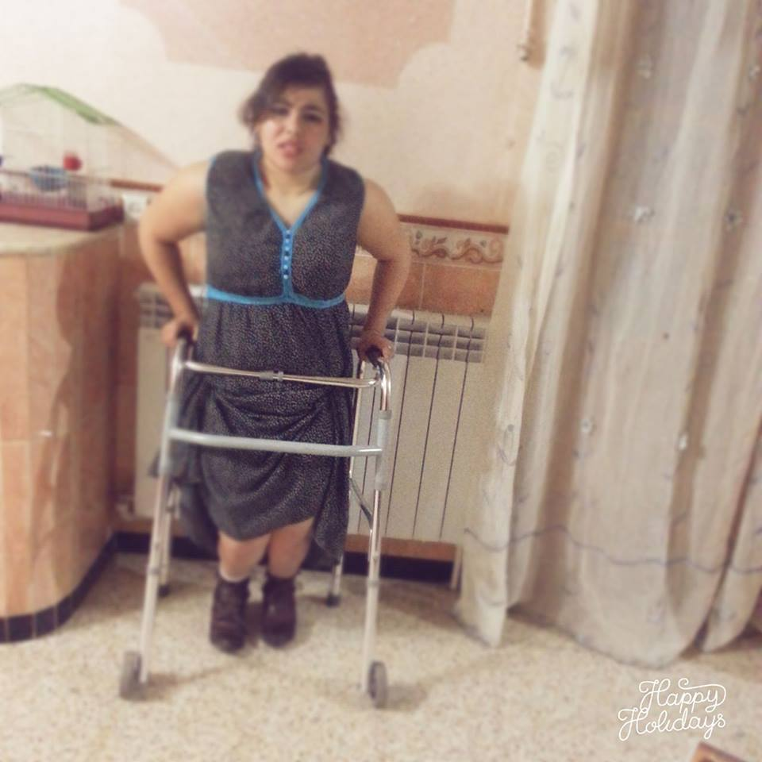

Appendix 02: Houda’s feet after the operation

Appendix 03: A picture of social inclusion and facilities
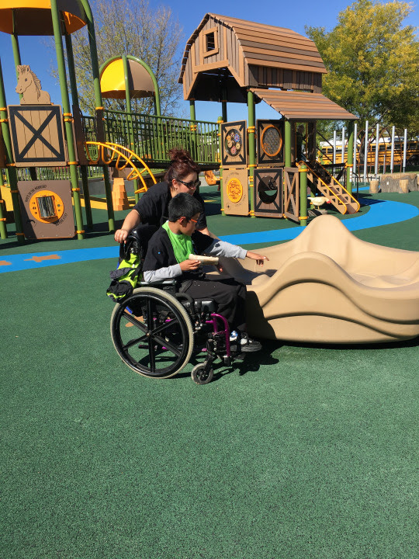

Commission Nationale Consultative de Promotion et de Protection des Droits de l’Homme, 2009.
http://www.ons.dz/

